Methods
Country-level panel models were used to evaluate associations between health workforce density, government health financing and service-coverage outcomes. Country fixed effects controlled for all observed and unobserved time-invariant country characteristics, while year fixed effects accounted for common temporal shocks. For each outcome, fixed-effects and random-effects specifications were estimated and compared using the Hausman specification test. Fixed effects were retained when the test indicated systematic differences between the estimators, suggesting correlation between country-specific effects and the regressors. Random effects were used only when the Hausman null was not rejected.
UHC Service Coverage Sub Index on Reproductive, Maternal, Newborn, and Child Health (RMNCH)
We compared the fitted fixed effects and random effects model. The Hausman specification test strongly rejected the random-effects model for RMNCH service coverage (χ² = 60.66, df = 27, p < 0.001), indicating that country-specific effects were correlated with the explanatory variables. Consequently, the fixed-effects model was adopted for inference.
In the fixed-effects model, neither physician density (β = −0.173, p = 0.088), nursing and midwifery density (β = 0.008, p = 0.834), government health expenditure (β = −0.169, p = 0.728), nor population density (β = −0.001, p = 0.949) showed statistically significant within-country associations with RMNCH service coverage. However, significant positive year effects from 2012 onwards indicated substantial temporal improvements in RMNCH service coverage independent of the measured workforce and financing variables.
From the piece wise regression, the estimated kink term capturing a change in marginal returns above the estimated threshold was not statistically significant (β = 0.043, p = 0.72), indicating no evidence of a discrete breakpoint in the workforce - RMNCH relationship.
Grid-search optimization suggested a candidate workforce threshold of approximately 10 health workers per 10,000 population. However, the corresponding piecewise fixed-effects model did not demonstrate a statistically significant change in slope after this breakpoint (β = 0.218, p = 0.171). Thus, although the relationship appeared nonlinear descriptively, there was insufficient evidence to conclude that RMNCH service coverage exhibits a distinct workforce threshold in this dataset.
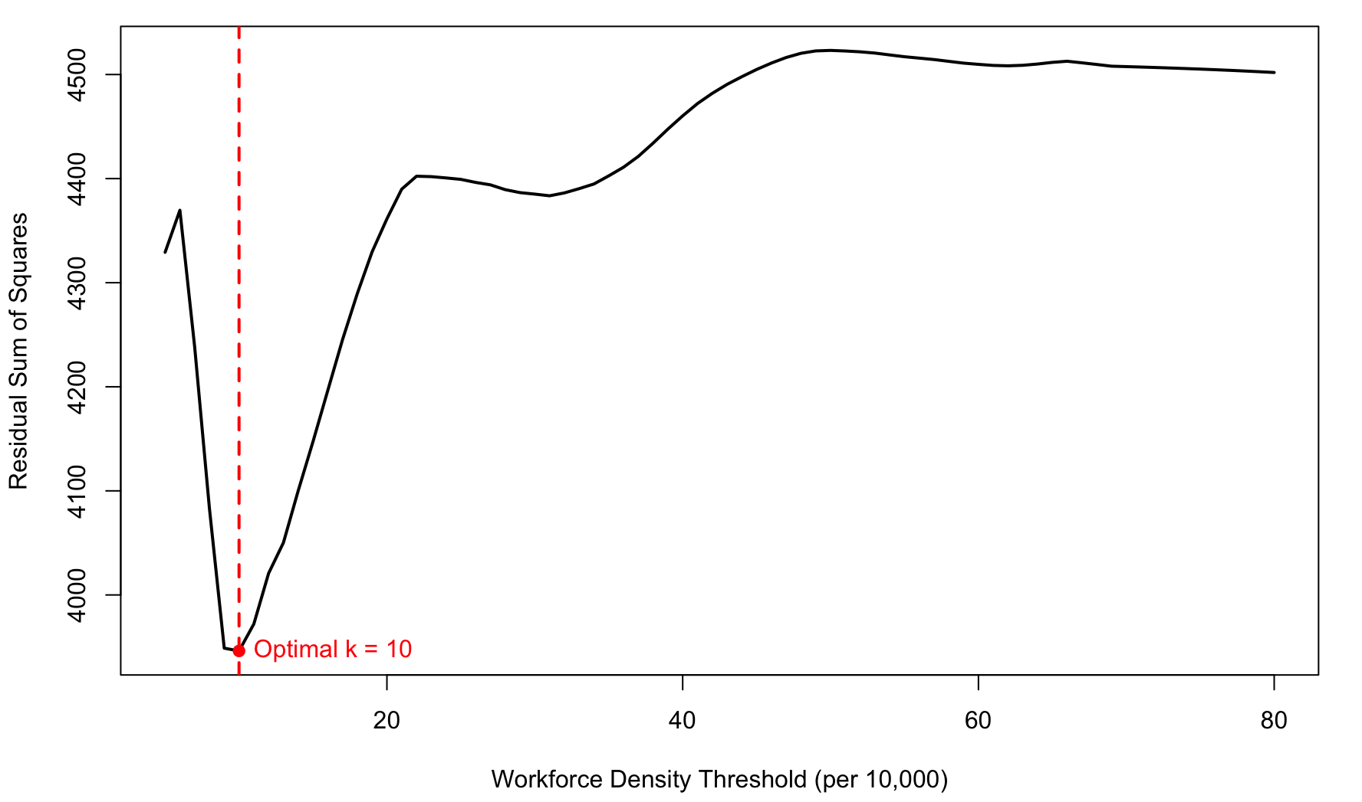
Figure A1: Workforce density threshold for RMNC

UHC Service Coverage Sub Index on Noncommunicable Diseases (NCD)
The Hausman specification test did not reject the null hypothesis for the NCD Service Coverage Index (χ² = 28.87, df = 27, p = 0.367), indicating that the random-effects model was appropriate. In the preferred model, population density was positively associated with NCD service coverage (β = 0.022, p < 0.001), whereas physician density, nursing and midwifery density, and government health expenditure were not statistically significant. Positive and significant year effects from 2003 onwards indicated substantial temporal improvements in NCD service coverage across the study period.
Grid-search optimization identified an empirical breakpoint of approximately 19 health workers per 10,000 population for the NCD Service Coverage Index. In the random-effects piecewise regression with cluster-robust standard errors, workforce density was positively associated with NCD service coverage below the breakpoint (β = 0.192, p = 0.066), whereas the change in slope after the breakpoint was negative (β = −0.209, p = 0.055), indicating a flattening of the relationship beyond 19 health workers per 10,000 population. Although the change in slope narrowly missed conventional statistical significance, the findings suggest diminishing marginal returns of workforce expansion at higher workforce densities.

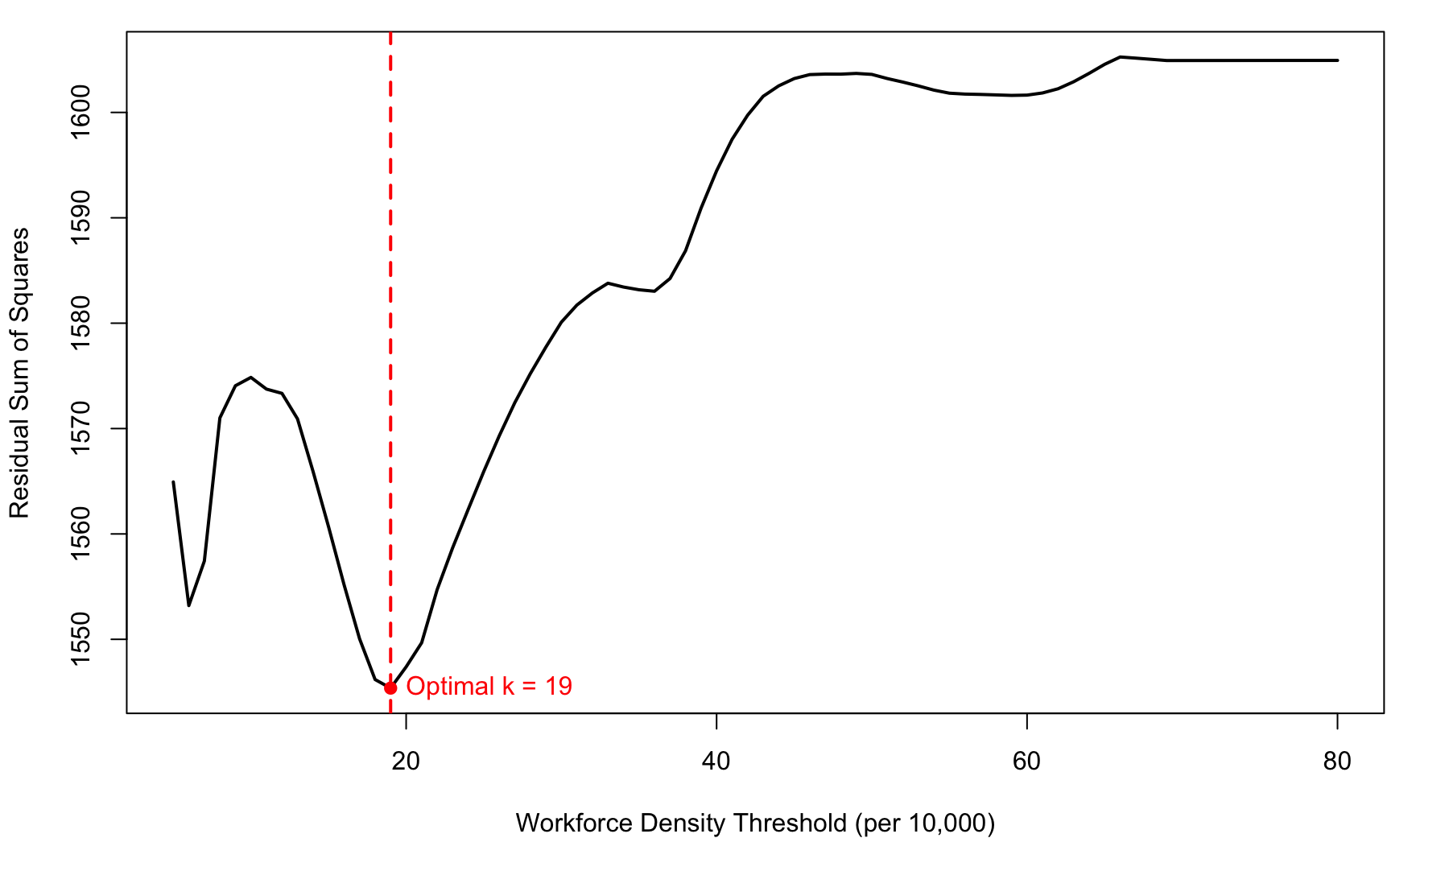
Figure A2: Workforce density threshold for NCDs coverage index

UHC Service Coverage Sub Index on Infectious Diseases
The Hausman specification test strongly rejected the random-effects assumption for the Infectious Disease Service Coverage Index (χ² = 129.8, df = 27, p < 0.001), indicating that unobserved country-specific effects were correlated with the explanatory variables. Consequently, fixed-effects models were used to estimate the association between health workforce density and infectious disease service coverage.
Grid-search analysis identified an apparent threshold of approximately 7 health workers per 10,000 population for the infectious disease service coverage index. However, in the piecewise panel regression, neither the pre-threshold workforce effect (β = 0.84, p = 0.21) nor the change in slope after the threshold (β = −0.98, p = 0.14) reached statistical significance. These findings suggest that, unlike the overall UHC and NCD service coverage indices, infectious disease service coverage does not exhibit strong evidence of a distinct workforce threshold.
There is also a secondary local minimum observed around 37 health workers per 10,000 population. The presence of multiple local minima suggests that the workforce–service coverage relationship is unlikely to be characterized by a single, well-defined threshold. Instead, the relationship appears to be gradual and nonlinear.

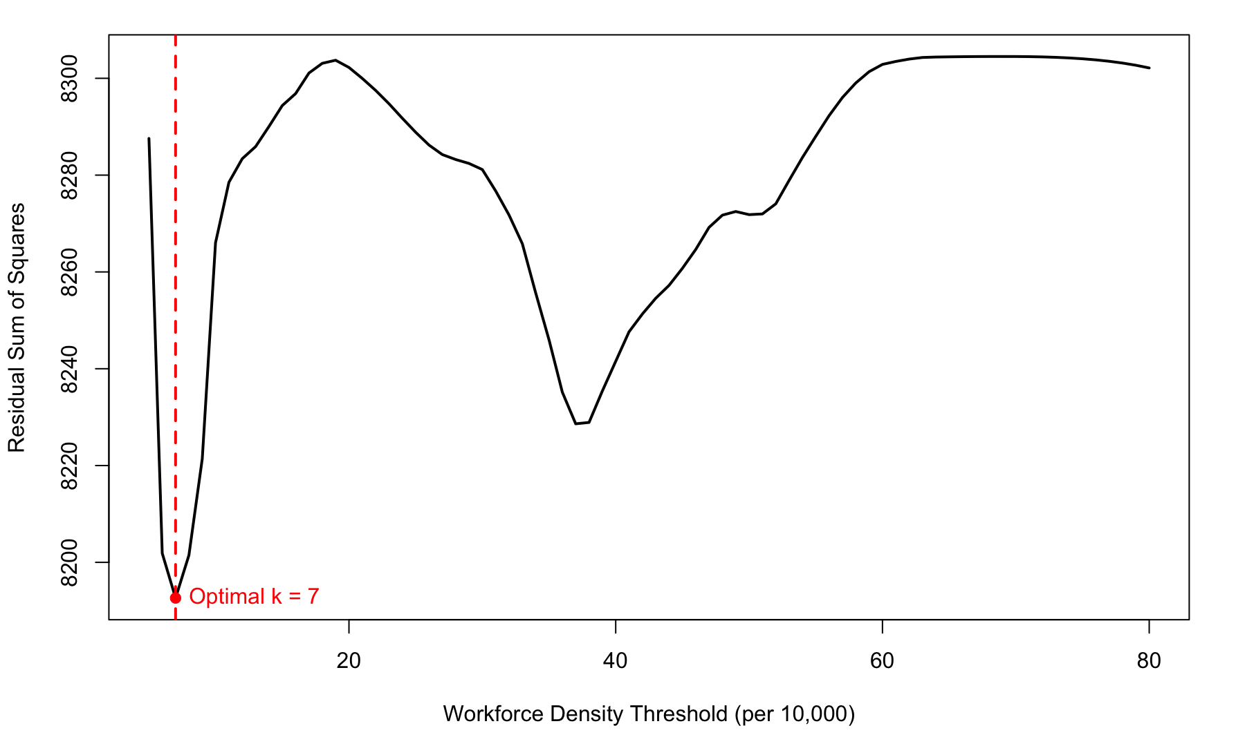
Figure A3: Workforce density threshold for infectious diseases
The analyses demonstrate substantial heterogeneity in the workforce–service coverage relationship across UHC domains. RMNCH and infectious disease service coverage showed no statistically supported workforce threshold despite having breakpoints identified through grid-search optimisation. In contrast, NCD service coverage exhibited evidence suggestive of a plateau at approximately 19 health workers per 10,000 population, indicating diminishing marginal returns to workforce expansion at higher workforce densities. These findings suggest that workforce benchmarks may need to be tailored to specific service domains rather than relying on a single universal threshold.

References

To support methods
- Hausman, J. A. (1978). Specification tests in econometrics. Econometrica, 46(6), 1251–1271.
- Wooldridge, J. M. (2010). Econometric analysis of cross section and panel data (2nd ed.). MIT Press.
- Arellano, M., & Bond, S. (1991). Some tests of specification for panel data: Monte Carlo evidence and an application to employment equations. The Review of Economic Studies, 58(2), 277–297.
- Blundell, R., & Bond, S. (1998). Initial conditions and moment restrictions in dynamic panel data models. Journal of Econometrics, 87(1), 115–143.
- Hansen, B. E. (1999). Threshold effects in non-dynamic panels: Estimation, testing, and inference. Journal of Econometrics, 93(2), 345–368.
- Driscoll, J. C., & Kraay, A. C. (1998). Consistent covariance matrix estimation with spatially dependent panel data. The Review of Economics and Statistics, 80(4), 549–560.
- Roodman, D. (2009). A note on the theme of too many instruments. Oxford Bulletin of Economics and Statistics, 71(1), 135–158.
- Harrell, F. E., Jr. (2015). Regression modeling strategies: With applications to linear models, logistic regression, and survival analysis (2nd ed.). Springer.

Health workforce
- Anand, S., & Bärnighausen, T. (2004). Human resources and health outcomes: Cross-country econometric study. The Lancet, 364(9445), 1603–1609.
- Chen, L., Evans, T., Anand, S., Boufford, J. I., Brown, H., Chowdhury, M., Cueto, M., Dare, L., Dussault, G., Elzinga, G., Fee, E., Habte, D., Hanvoravongchai, P., Jacobs, M., Kurowski, C., Michael, S., Pablos-Méndez, A., Sewankambo, N., Solimano, G., Stilwell, B., de Waal, A., & Wibulpolprasert, S. (2004). Human resources for health: Overcoming the crisis. The Lancet, 364(9449), 1984–1990.
- GBD 2019 Universal Health Coverage Collaborators. (2020). Measuring universal health coverage based on an index of effective coverage of health services in 204 countries and territories, 1990–2019. The Lancet Global Health, 8(8), e1064–e1082.

